Welcome to

Central Library

M.R.R. Govt. Arts & Science Degree College
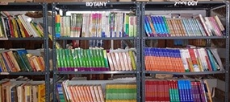
The college library serves as an essential information center, supporting the institution's educational goals. Our mission is to provide a comprehensive collection and quality services to facilitate learning and research.
With a well-curated collection, the library offers valuable resources for academic studies and competitive exam preparation.
We invite you to visit and make the most of the resources available on our shelves!
.
